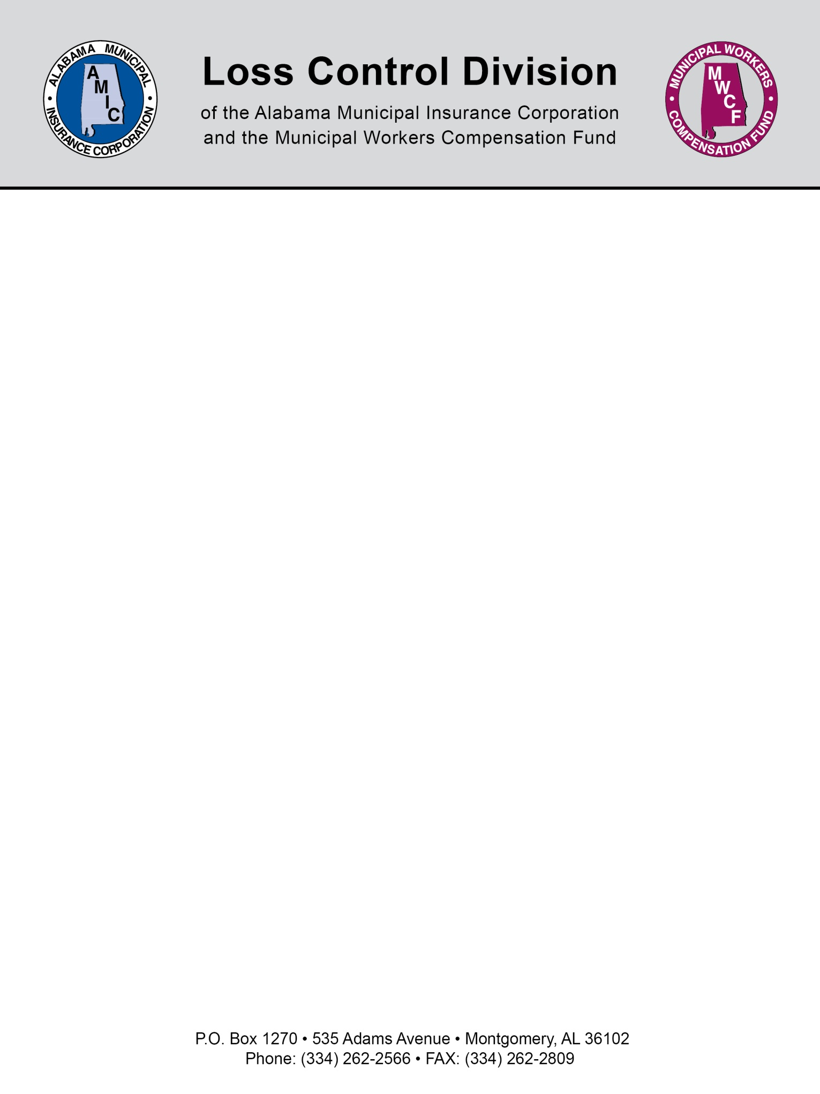

Non-Employees Riding in Municipal Vehicles

The AMIC/MWCF Loss Control Division recommends that you adopt a written policy prohibiting non-employees from riding in municipal vehicles unless it is directly related to municipal business or an emergency.

Why? Because passengers have no coverage unless additional endorsements are purchased.
This best practice recommendation is based on the idea of separating “acceptable exposures” from “unacceptable exposures” for both the municipality and your auto insurance carrier. A passenger in municipal vehicles has no coverage under a standard auto policy unless an additional endorsement is purchased for passenger medical payment coverage. Even then, such an endorsement is often limited to only $5,000 per passenger. What this means is that – should your municipal vehicle have an at-fault accident – the passenger has zero coverage under your unendorsed policy. The only recourse to recover money for passenger injuries is to sue the municipality, which can lead to understandably awkward situations if, for example, an employee has to sue his employer to cover the medical bills for his child because she was riding in his municipal vehicle.

Due to the lack of direct coverage under the auto policy, the municipal auto carrier can do nothing until the lawsuit is filed. At that point, the good news for the municipality is that your carrier would then step in and defend the municipality in the lawsuit. However, as with all lawsuits, the time and extra expenses involved in handling and settling a lawsuit could mean the final cost of that claim may well be substantially larger than the original medical bills incurred. So, while the good news is that the municipality had coverage for the lawsuit, the bad news is that the claim is now on the city’s loss run and will adversely affect renewal premiums, leaving the municipality to ask: “Should our premiums be going up because an employee decided to use his city vehicle for personal use?” And, while that’s a great question, the better question to ask would be: “Why did we as the city allow ourselves to be put in this situation?”

Acceptable vs. Unacceptable Exposure
This principle applies to ALL passengers in ALL municipal vehicles and, of course, there are times where having non-employees in municipal vehicles is unavoidable. Therefore, we must try to separate the “acceptable exposure” from the “unacceptable exposure.” For example, a senior center might use a 15-passenger van for senior trips. What happens if that van wrecks? The same process as described above: since none of those seniors has direct coverage, they will have to sue the municipality for their injuries. Again, at that point the auto carrier steps in and defends the municipality in the lawsuits and may well end up paying those medical bills. However, the major difference in this example is, from a risk management standpoint, it’s an acceptable exposure. Because this is a service the municipality is providing its citizens, it is, therefore, an acceptable risk for the municipality to take given that is what it is there to do: provide services for citizens.

Another example would be a police officer finding a lost child roaming the streets and picking him up to bring back to City Hall until the parents can be located. Does that child have coverage while riding in the police car? No. Is this an acceptable risk for the police officer to take? Protecting citizens is part of the scope of a police officer’s duties so, of course, the answer is yes. Clearly, there are many times when non-employees riding in municipal vehicles is due to a business need or part of a service being provided. These are all acceptable risks from a risk management standpoint.

However, there are times when a non-employee riding in a municipal vehicle is not an acceptable risk. For example, an employee using his city vehicle to pick up or drop off his children at school. Was the vehicle purchased with public money and underwritten for insurance purposes with that use in mind? Should that city be exposed to a potentially large and expensive lawsuit that could ultimately cause its auto premiums to go up because of an injury to a child riding in one of its vehicles? Could and should that exposure have been avoided by the city? Certainly, from the insurance carrier’s standpoint, a claim arising from such a situation should have never been allowed to happen and could have easily been avoided. So, from a risk management perspective, this is an example of an “unacceptable exposure.”

A final but again very common example is when an employee is being sent out of town for a few days to attend a conference. That conference happens to be at the beach and would be a great opportunity to take the family on a short vacation. So the employee loads up his spouse and children in his municipal vehicle and heads to the beach. Who will be sued for the large medical bills of the spouse and children if that vehicle has an at-fault accident? Since this is an approved business trip for the employee, he is probably covered under the city’s workers comp insurance. But what about his family? Was that a risk and claim the city could have avoided? Absolutely. Is that a lawsuit that the insurance carrier feels should not have happened? Yes. However, is it unfair to punish the employee by not allowing him to take his family while he’s out of town? The good news is that this issue can be resolved very easily. If an employee is going alone or with only other employees, then he can take a municipal vehicle. But if he wants to take a non-employee with him, he needs to use his personal vehicle and get reimbursed for the mileage or gasoline. After all, an employee shouldn’t be penalized for going on the trip – and he wouldn’t have paid for the gas if he’d used a city vehicle.

Conclusion
This can be a complex and thorny issue for many municipalities. Some have allowed employees to use city vehicles for personal use for many years as long as it didn’t interfere with business. Little did they know the added risk and exposure this practice creates for the city. From a risk management viewpoint, it is certainly a best practice to review the use of your municipal vehicles and ask yourself: “Is this an acceptable or unacceptable risk?” In doing so, keep in mind that, from your insurance carrier’s perspective, the answer may not be the same as yours.

NOTE: This document is not intended to be legal advice. It does not identify all the issues surrounding the particular topic. Public agencies are encouraged to review their procedures with an expert or an attorney who is knowledgeable about the topic. Reliance on this information is at the sole risk of the user.

Revised 11/2013

